Walkthrough-1

<https://sapui5.hana.ondemand.com/#/topic/2680aa9b16c14a00b01261d04babbb39>

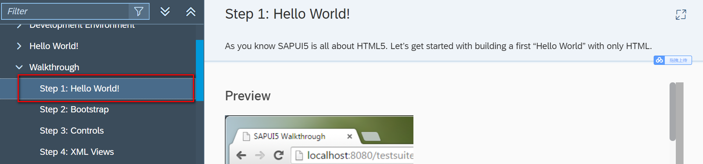

Code:

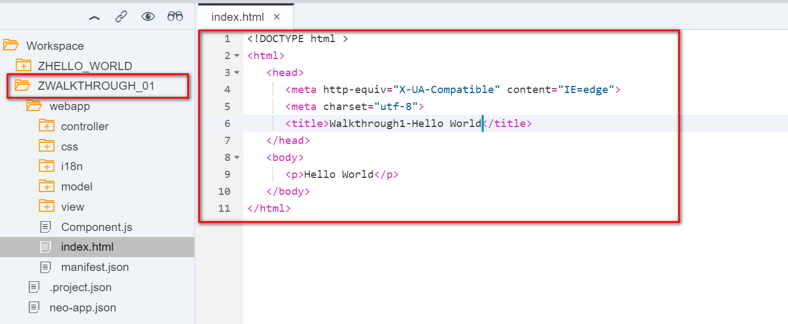

Result:

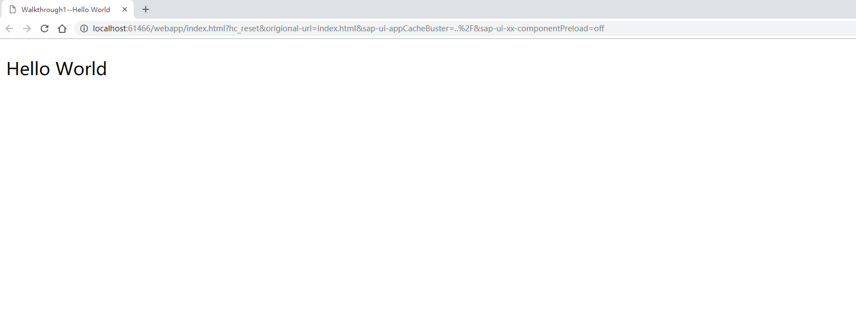

2018/11/01 Beijing Xiaomi Zac.Xie